**Introduction to Open-Source Software**

B. Tech Integrated /Computer / Sem IV

**Experiment No.09**

**(PART - B)**

# (TO BE COMPLETED BY STUDENTS)

(Students must submit the soft copy as per following segments within two hours of the practical.

The soft copy must be uploaded on the Blackboard or emailed to the concerned lab in charge faculties at the end of the practical in case there is no Black board access available)

|  |  |
| --- | --- |
| Roll.No. : C092 | Name: Karan Dave |
| Sem/Year : Sem 4/ year 2 | Batch: C1 |
| Date of Experiment : | Date of Submission: |
| Grade -- |  |

**B.1: Procedure of performed experiment**

Write an algorithm and draw a flowchart to display the total water bill charges of the month depending upon the number of units consumed by the customer as per the following criteria: • for the first 100 units @ 5 per unit • for next 150 units @ 10 per unit • more than 250 units @ 20 per unit Also add meter charges of 75 per month to calculate the total water bill.

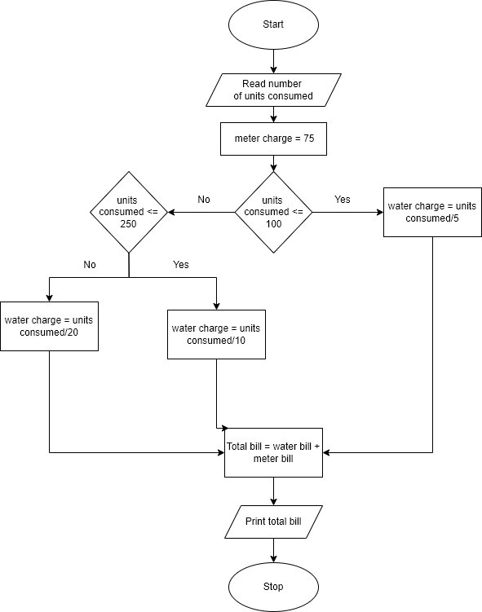

Draw a flow chart for finding roots of a quadratic equation

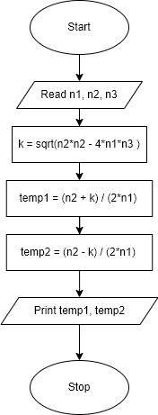

Draw flow chart for finding greatest of three numbers.

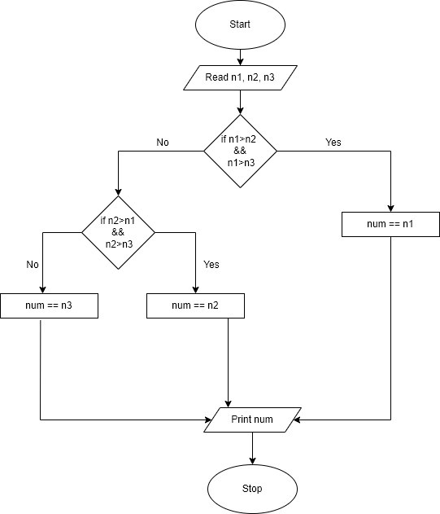

**B.2: Observations and Learning’s:**

Using different shapes flowchart was made, which helps a programmer to code in sequential manner.

**B.3: Conclusion:**

Successfully completed study and making of flowchart.